R-CALF USA & Oklahoma Independent Stockgrowers Association
are coming to a town near you!

Bill Bullard, CEO of R-CALF USA, will be the guest speaker for March’s OISA regional meetings.
OISA and R-CALF USA strive to exclusively represent the American cattle producer.
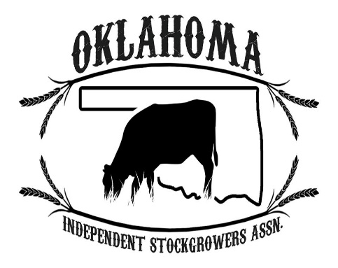

Wed., March 28 - Woodward Sale Barn (900 Lakeview Dr., Woodward, OK). Dinner will be at 6:30 p.m. (at cost to you) Meeting will be held at 7:30 p.m.
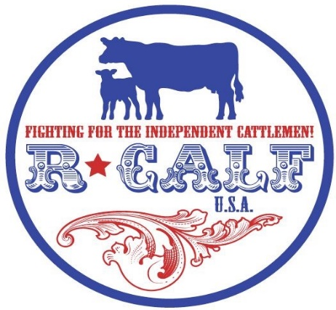
Thurs., March 29 – Northwest Livestock west of Enid 11802 W Garriott Enid, Oklahoma 73703. You can catch lunch at the sale barn (opens at 11:00) Meeting starts at 1:00 pm
Fri., March 30 – Purcell Multipurpose Center (1400 Chandler Rd., Purcell, OK). Hamburger feed starts at 5:30 p.m. Sponsored by Dr. Christina Makarim and friends DVM.
Sat., March 31 – Durant Stockyards (2201 S 9th Avenue, Durant, OK). Meeting will begin at 7:30 p.m.

